# COSC2446 Web Programming

## Practical Assessment 2 (worth 20%)

## Due date is 24th September 2021

Develop a website to provide information about courses in a College.

* Write an SQL script to set up a table **CourseDetails** in a database **RoyalCollege**, with fields for a unique course_id (serial primary key), course_code (varchar), course_name (varchar), subject (varchar), instructor (varchar), weeks (integer) and description (text). Ensure you call your database **RoyalCollege** and table **CourseDetails**, so that I can recreate your site on my computer. Make sure case matches. No need to add data to this table in the script. you can check following examples for more clarity.
  + code is a typical course code such a **LIT101**
  + name is the name of the course e.g. **English Literature**
  + subject is the general subject area e.g. **Literature**
  + instructor is the name of the instructor
  + weeks is how long the course runs for e.g. 8 weeks.
  + description is a paragraph or so describing the course content
* Use the include() function to place a file header.inc, nav.inc and footer.inc into all your pages. The unique content on each page is inside a **main** element.

**(check week 8 notes for include function)**

* + header.inc contain the head element and top of the body with a **header** element for the site banner.
  + nav.inc includes a **nav** element with links to the required pages
  + footer.inc contains a **footer** element with your copyright notice, and the closing page tags
* Each page must be 1100px wide, centered in the browser window, using a wrapper div or other means to contain all content. Don’t use Bootstrap or other framework for this. It must have a banner across the top 120px high with some site title. Each page has a horizontal navigation below the top, 40px high, with links to Home, Courses, Subjects, Instructors and Add.
* Home is the home page (index.php). This page needs to have some content to fill up some space.



* Add (add.php) is a form to add a new course. Include form elements for all fields except the id, which is generated by the database. Form should also include a file upload option to upload a word document (like detailed weekly schedule for that course) required for the course. Write a processing script to add the data from the form to the database and to upload files into the directory Course_Guide on your server (check **updated_library example with file upload** on canvas).

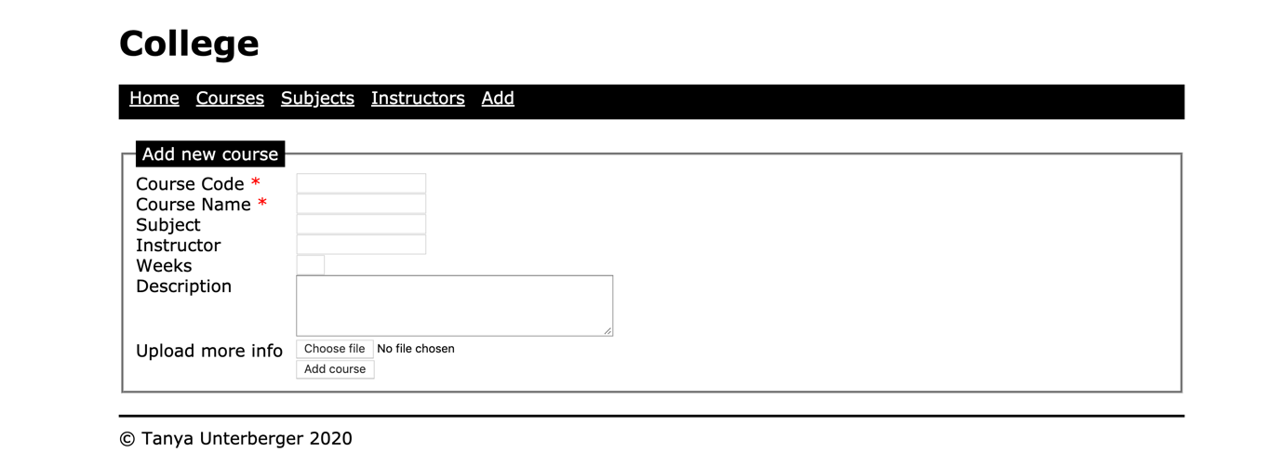

* Courses (courses.php) lists all details in an HTML table with column headings across the top.



Don’t display the course_id and the description. The course_code is a hyperlink to a page course.php, which displays all the data for the selected course. Use the course_id in the query string, not the course name.



* Subjects (subjects.php) lists all subjects from the database and a hyperlink (under subject) to a page subject.php, which uses a query string to display only the courses that belong to that subject.
* Instructors (instructors.php) lists all the instructors from the database and a hyperlink (under instructor name) to a page instructor.php, which uses a query string to display only the courses taught by that instructor.
* Use separate files for common content (the include files) and an external style sheet
* You need to create a folder with your name and submit the following files

1. **course.sql**
2. **header.inc, footer.inc, nav.inc**
3. **course.css**
4. **index.php**
5. **courses.php** (will display all the courses from the database with hyperlink under name)
6. **course.php** (display details about single course selected in courses.php)
7. **subjects.php (**will display all the subjects the database with hyperlink under subject)
8. **subject.php** (display details about single subject selected in subjects.php)
9. **instructors.php**(will display all the instructors from the database with hyperlink under instructor)
10. **instructor.php** (display details about single instructor selected in instructors.php)
11. **add.php** (including file upload) and processing script
12. Directory with name **Course_Guide** for uploading all the course information

* Zip up your folder and upload on Canvas.

Marks: 20% of total score for the course. Teacher can ask to any Student to give demonstration for this assignment to validate the work.

**Check another file for marking Criteria**